Math 1 Name ________________________
2-3 Introduction to Functions Date________

- I can interpret function notation and explain how the output of a function is matched to its input.
- I can interpret the meaning of an ordered pair

Frank is an employee at Burger Castle and earns $7.30 per hour, working the front counter. His salary is calculated by using the rule $y=7.30x$, where $x$ denotes the number of hours he works and $y$ denotes his total salary.
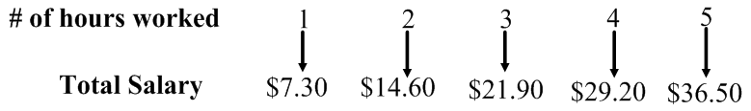

We will name this function by using function notation: $f\left(x\right)=7.30x$

$f\left(1\right)=$________, $f\left(2\right)=$________, ________= $29.20, ________= $36.50

Explain what f (1) = 7.30 means in this problem situation.

$f\left(8\right)=$________, $f\left(28\right)=$_________, ________= $109.50, ________= $153.30

Sally also works at Burger Castle, but she earns $8.15 per hour and a $15.00 bonus for working the late shift. Her salary is calculated by using the rule $y=8.15x+15$, where $x$ denotes the number of hours she works and $y$ denotes her total salary.
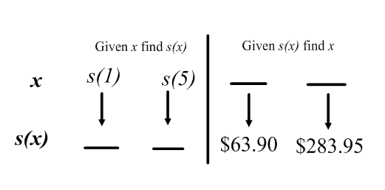
We will name this function by using function notation: $s\left(x\right)=8.15x+15$

Solve problems 1-3 and write your answer using function notation.
1. If Sally worked for 38 hours, then what would be her total salary?

2. If Sally made $235.05, then how many hours did she work?

3. Sally earned $178.00 and $357.30 during two weeks of work. How many hours did Sally work for those two weeks?

4. Explain why Sally’s total salary is a function of hours worked.
OVER
Function Practice:
$f\left(x\right)=3x$ Write as an ordered pair (x, f(x))

$f\left(1\right)=$______ ( _______ , _______ )

$f\left(2\right)=$______ ( _______ , _______ )

$f\left(-5\right)=$_____ ( _______ , _______ )

$f\left(1.5\right)=$______ ( _______ , _______ )

______ ( _______ , _______ )

$f\left(0\right)=$______ ( _______ , _______ )

Find the value of x when f(x) = 15. ( _______ , _______ )

Find the value of x when f(x) = 0. ( _______ , _______ )

Find the value of x when f(x) = -12. ( _______ , _______ )

Find the value of x when f(x) = 10.5. ( _______ , _______ )

Find the value of x when f(x) = -15. ( _______ , _______ )

Write a function rule, in function notation, that could result in the following ordered pairs:



   

